[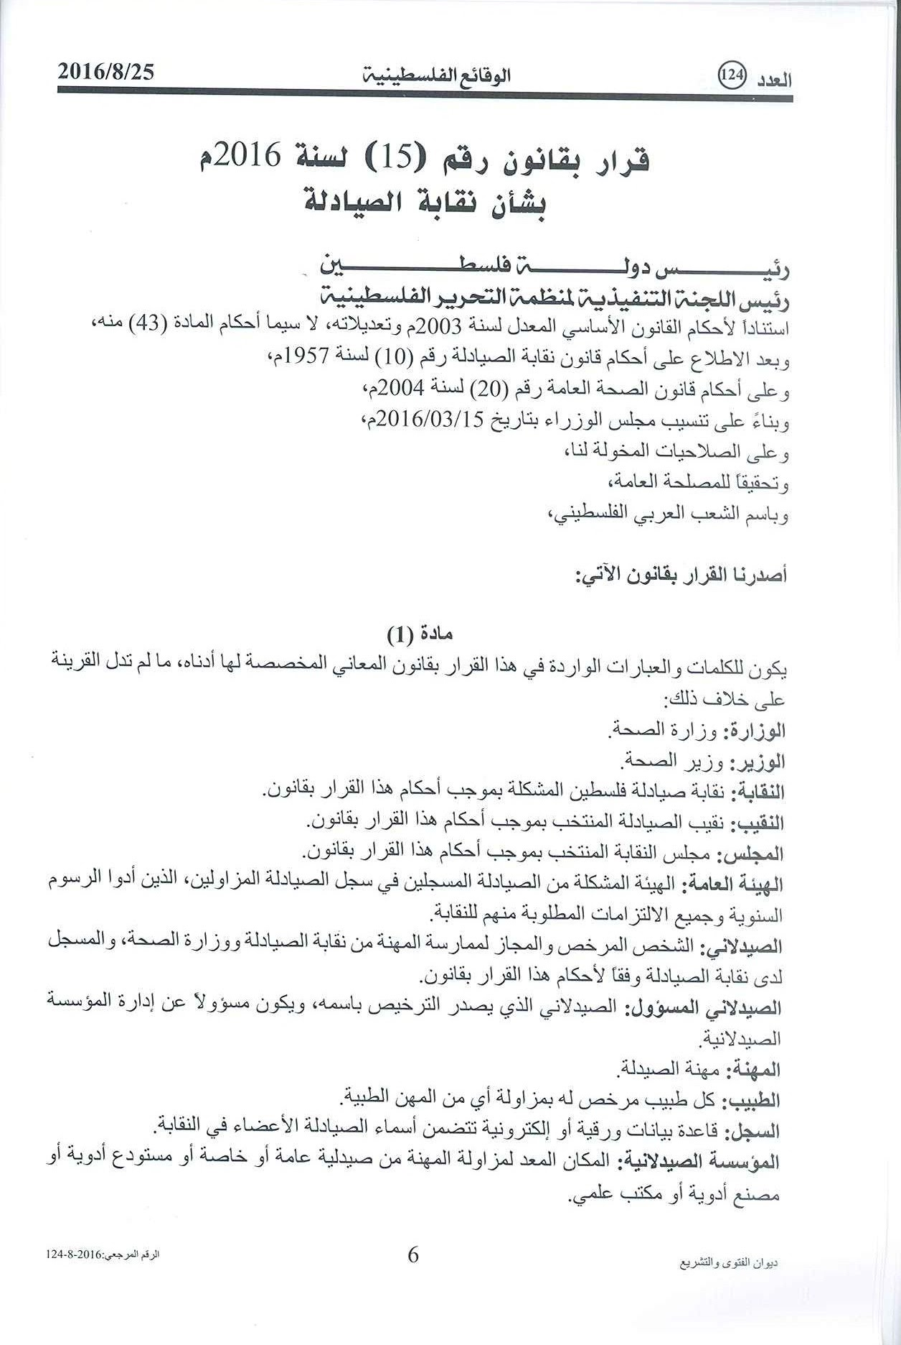](https://sites.google.com/site/ppasite2/home/News/qanwnnqabtealsyadlte/6.jpg?attredirects=0)

[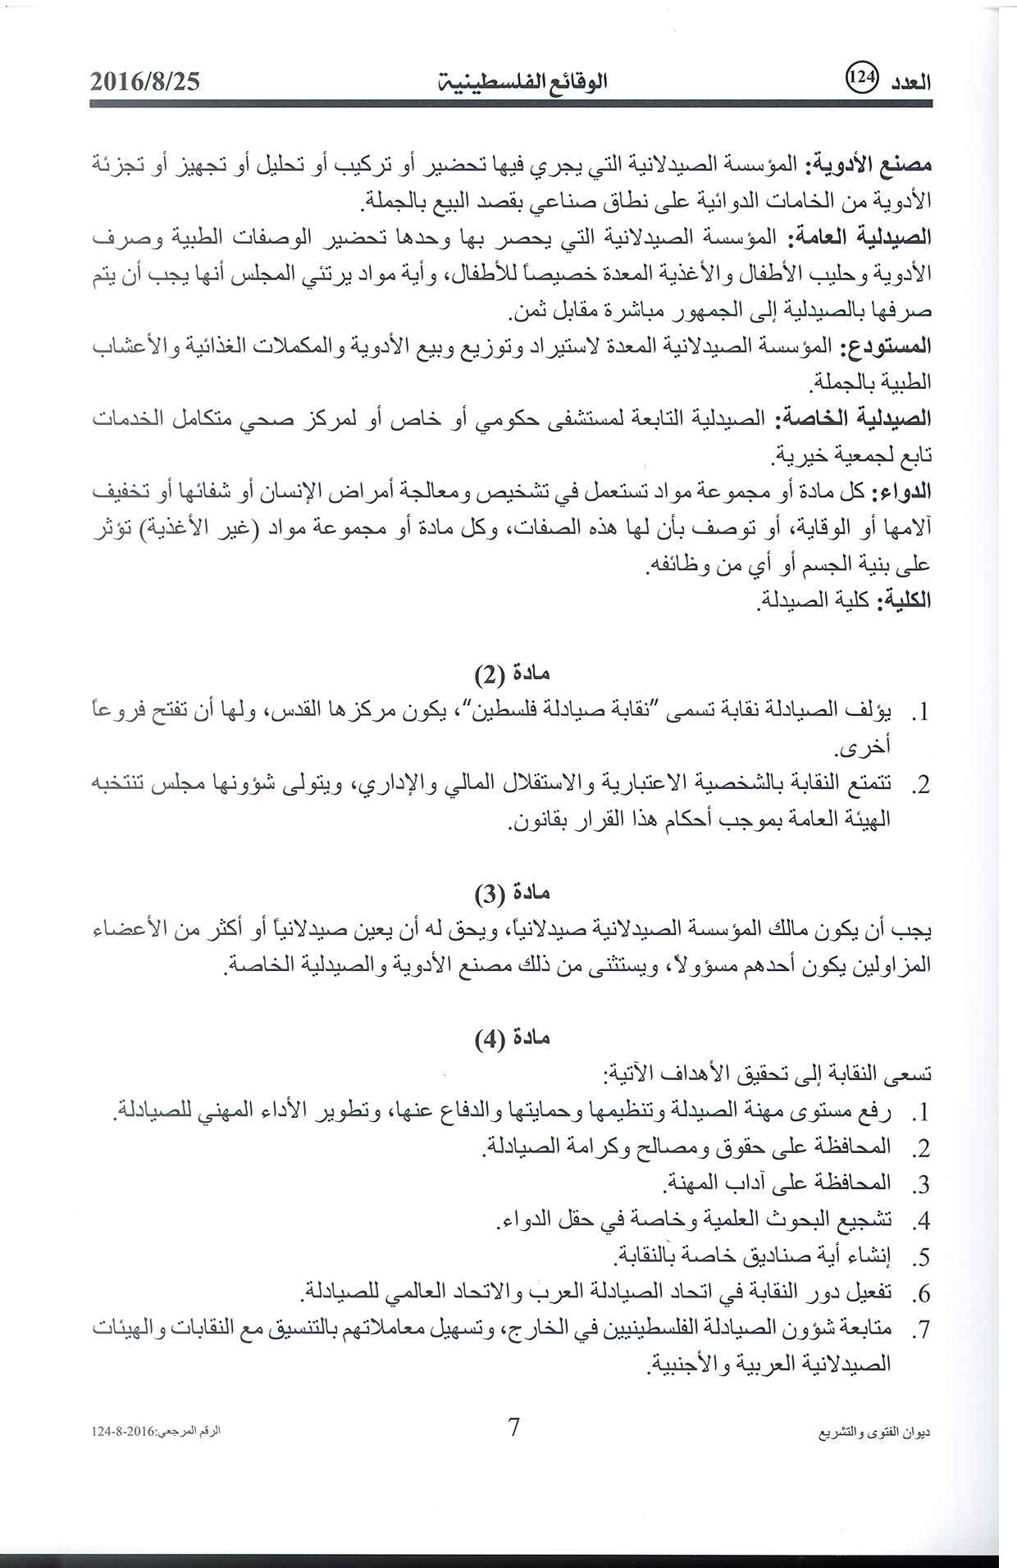](https://sites.google.com/site/ppasite2/home/News/qanwnnqabtealsyadlte/7.jpg?attredirects=0)

[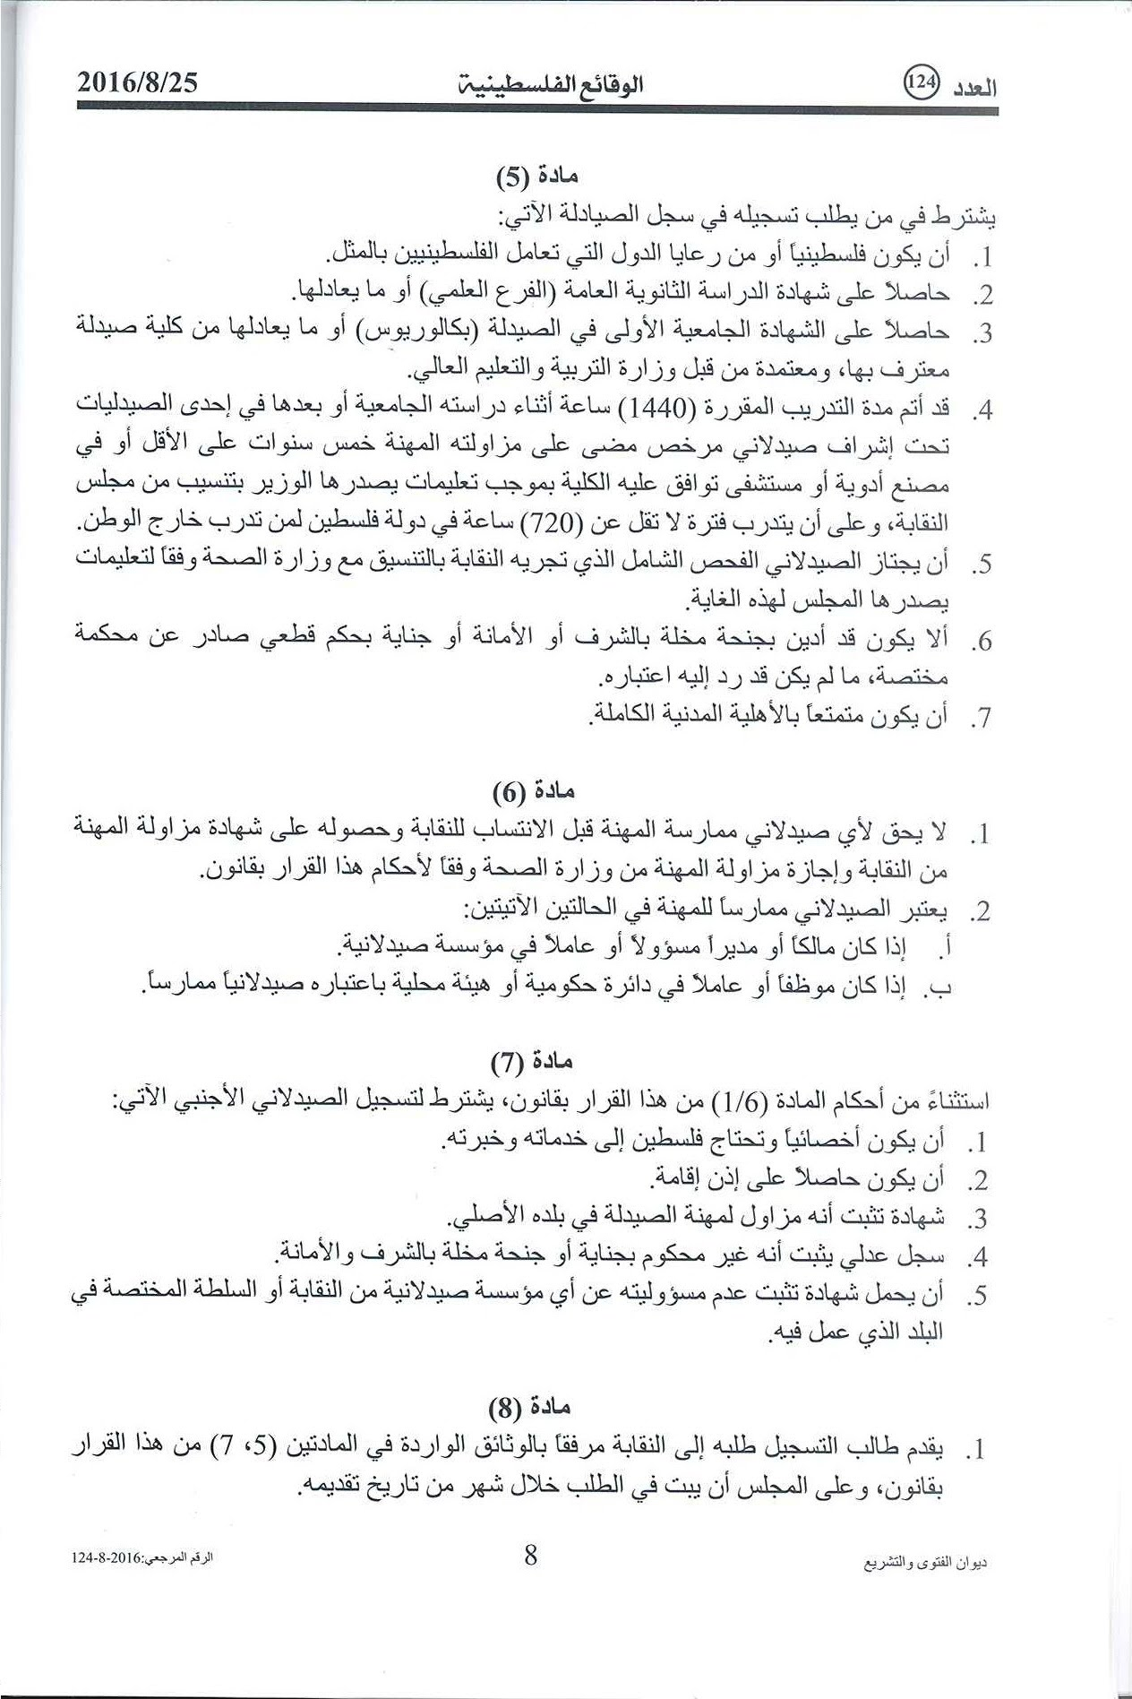](https://sites.google.com/site/ppasite2/home/News/qanwnnqabtealsyadlte/8.jpg?attredirects=0)

[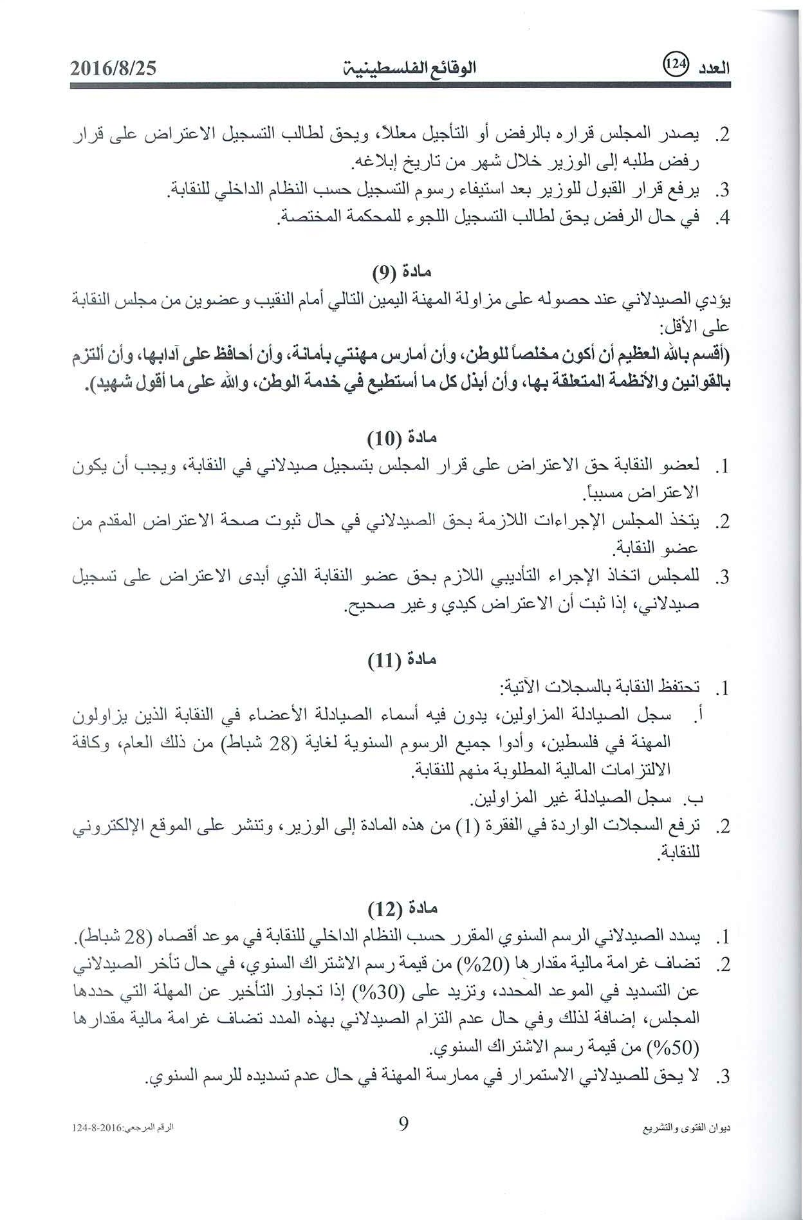](https://sites.google.com/site/ppasite2/home/News/qanwnnqabtealsyadlte/9.jpg?attredirects=0)

[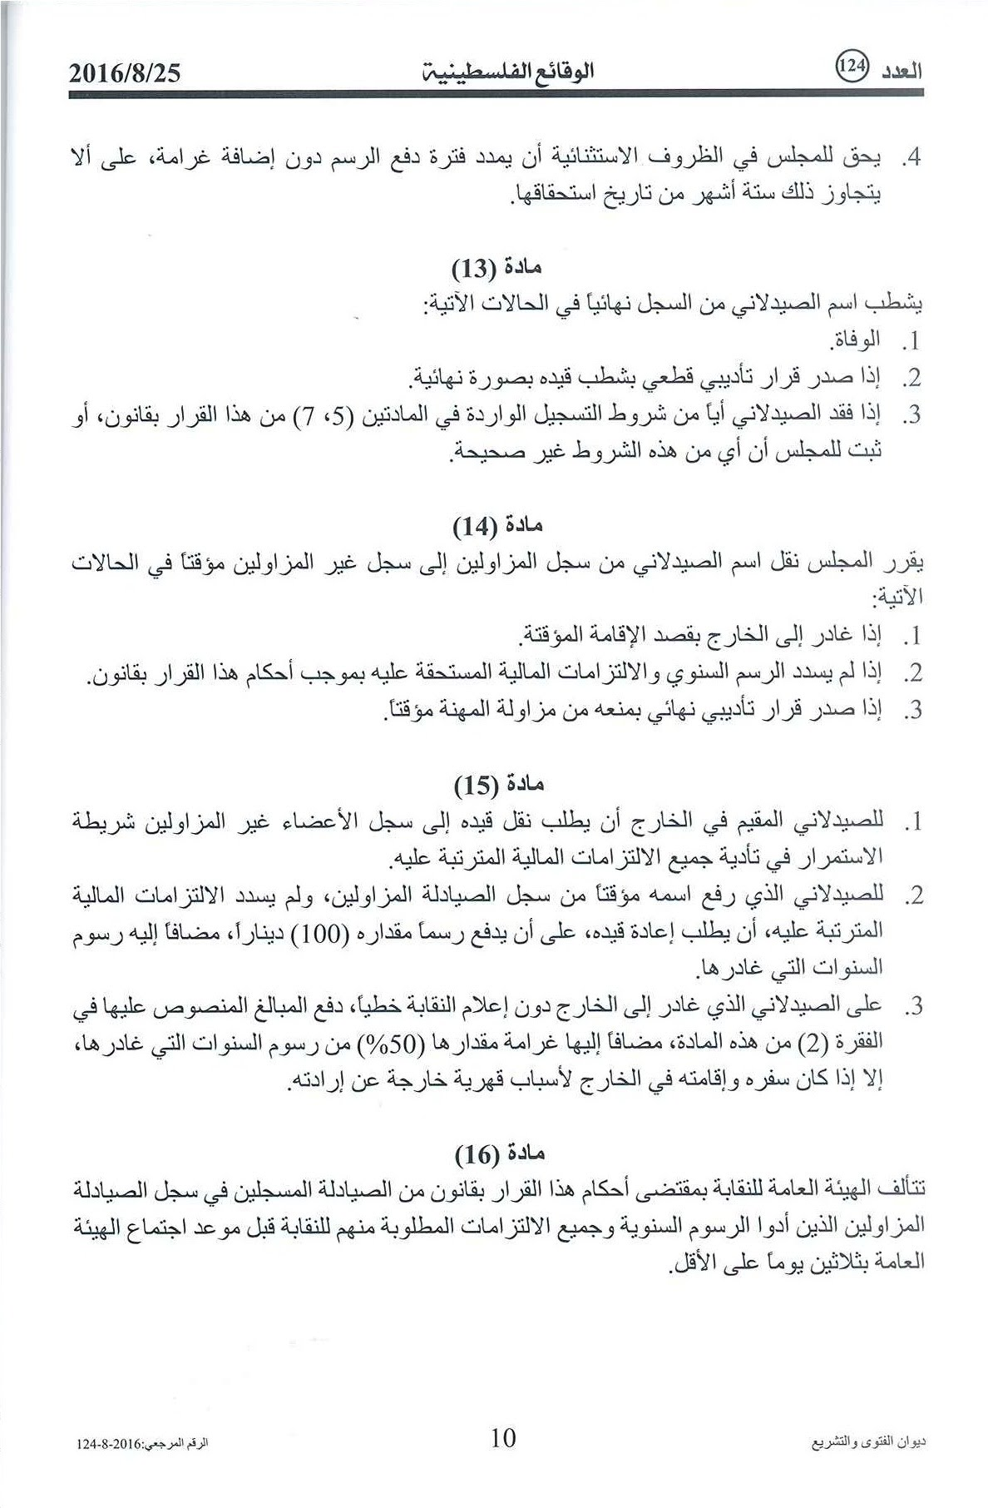](https://sites.google.com/site/ppasite2/home/News/qanwnnqabtealsyadlte/10.jpg?attredirects=0)

[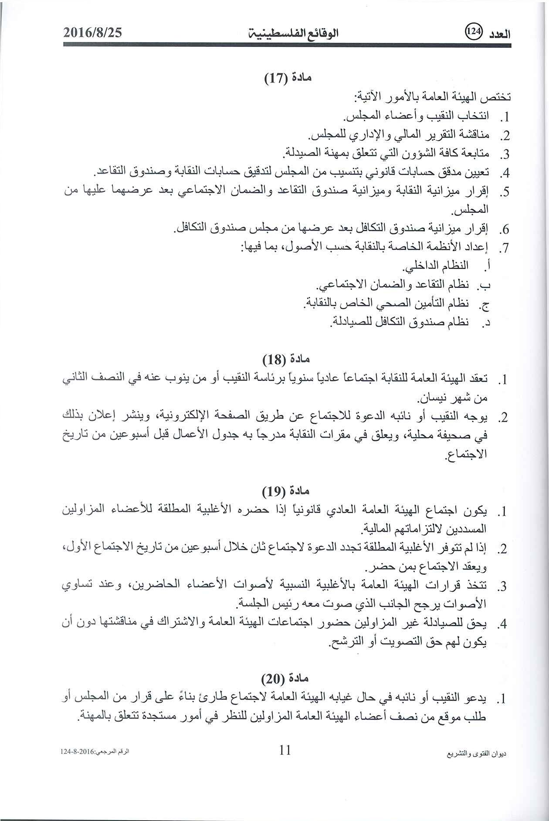](https://sites.google.com/site/ppasite2/home/News/qanwnnqabtealsyadlte/11.jpg?attredirects=0)

[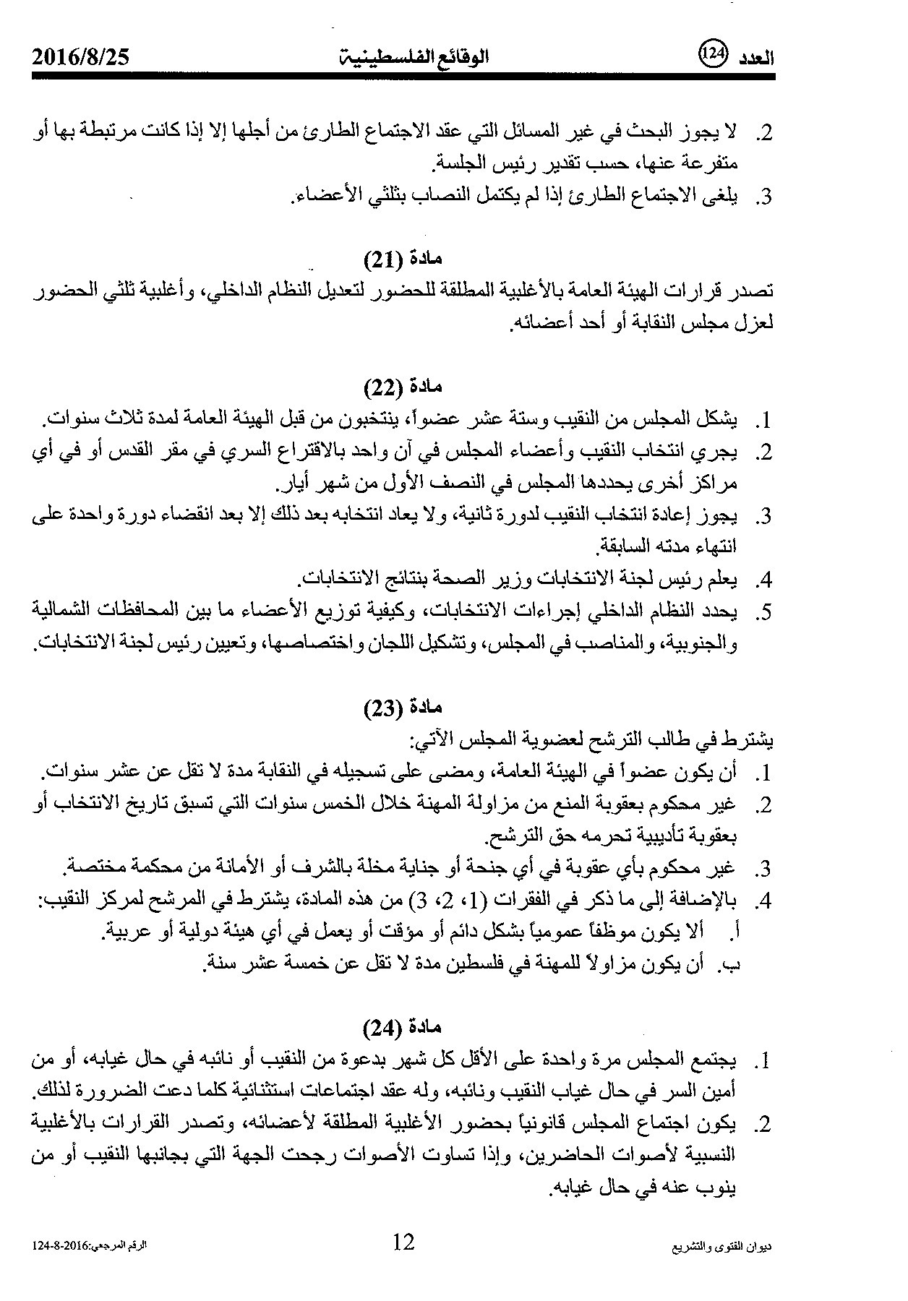](https://sites.google.com/site/ppasite2/home/News/qanwnnqabtealsyadlte/12.jpg?attredirects=0)

[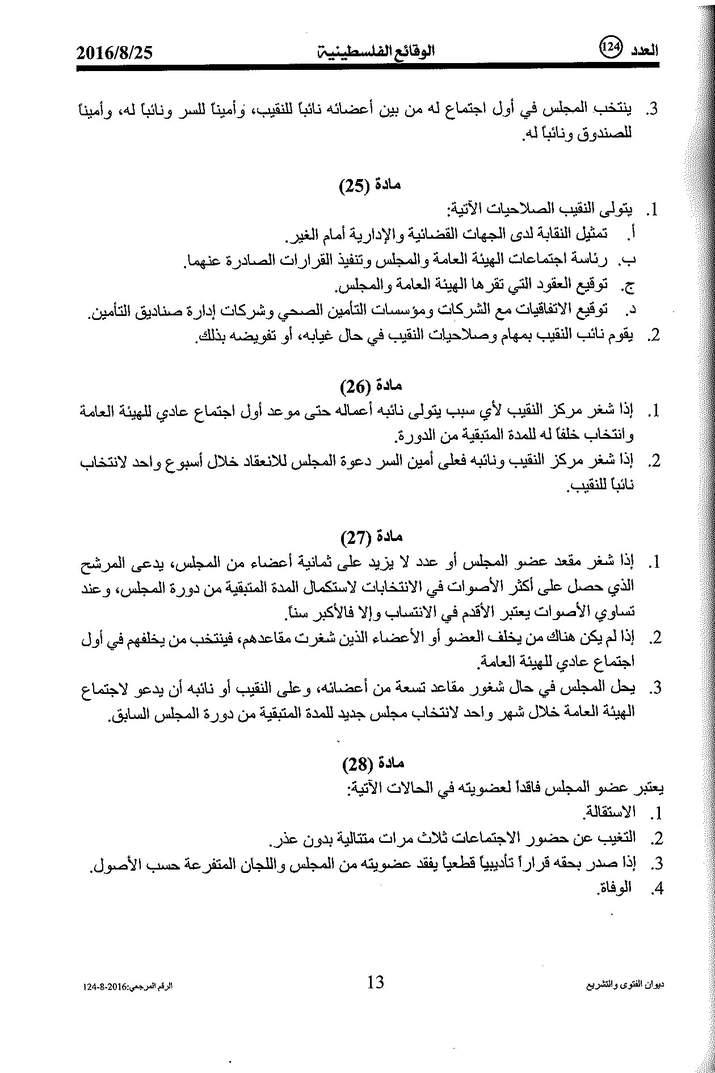](https://sites.google.com/site/ppasite2/home/News/qanwnnqabtealsyadlte/13.jpg?attredirects=0)[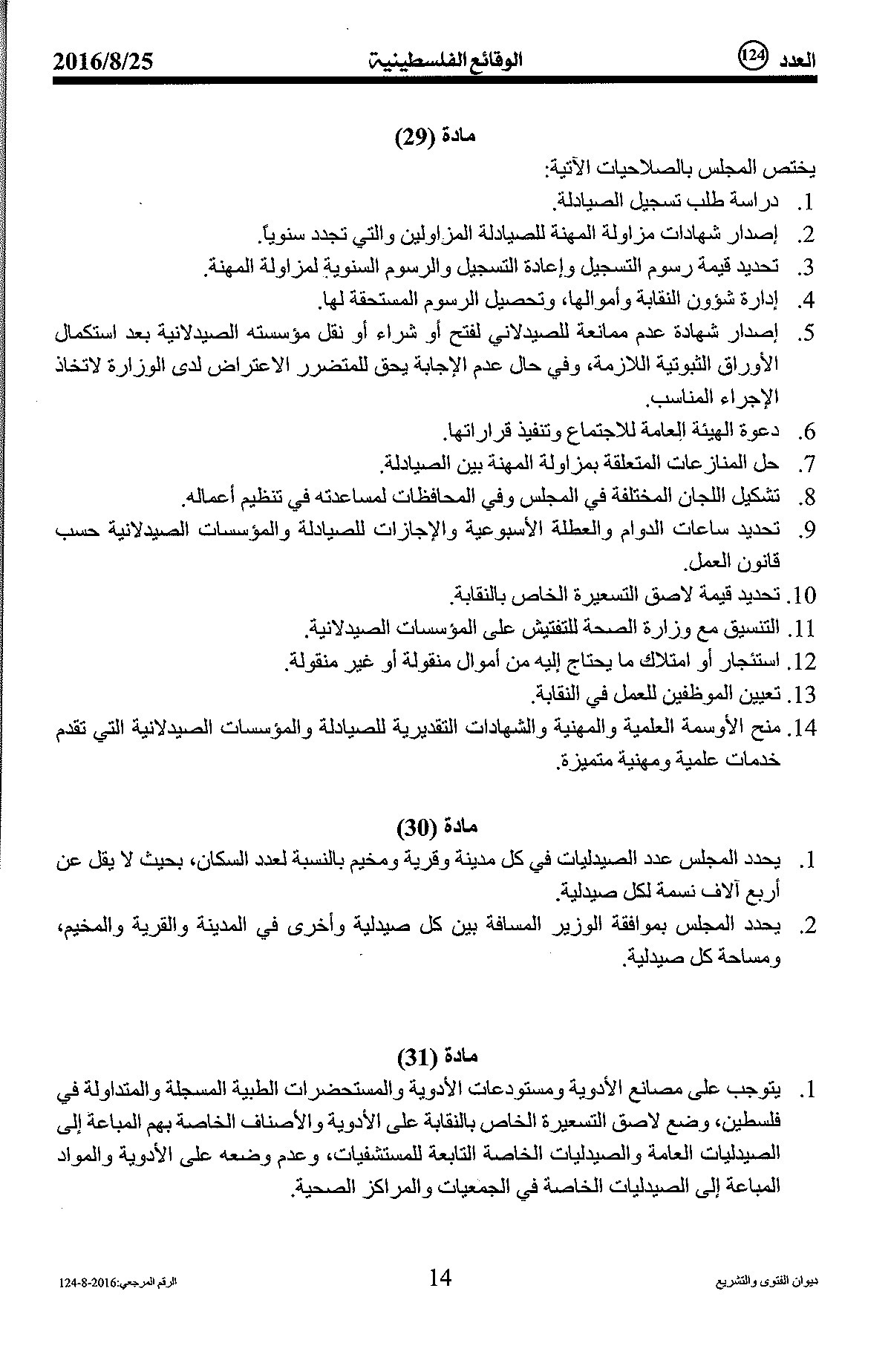](https://sites.google.com/site/ppasite2/home/News/qanwnnqabtealsyadlte/14.jpg?attredirects=0)

[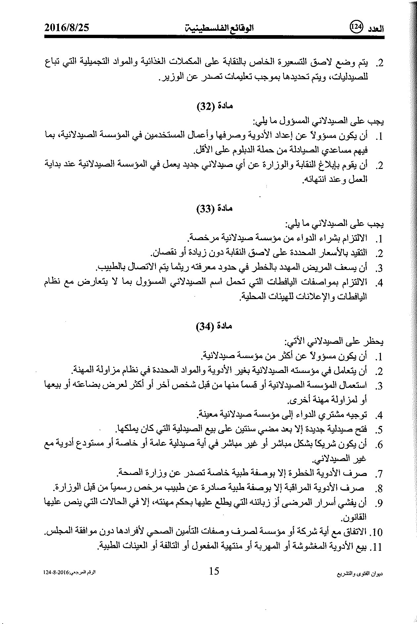](https://sites.google.com/site/ppasite2/home/News/qanwnnqabtealsyadlte/15.jpg?attredirects=0)

[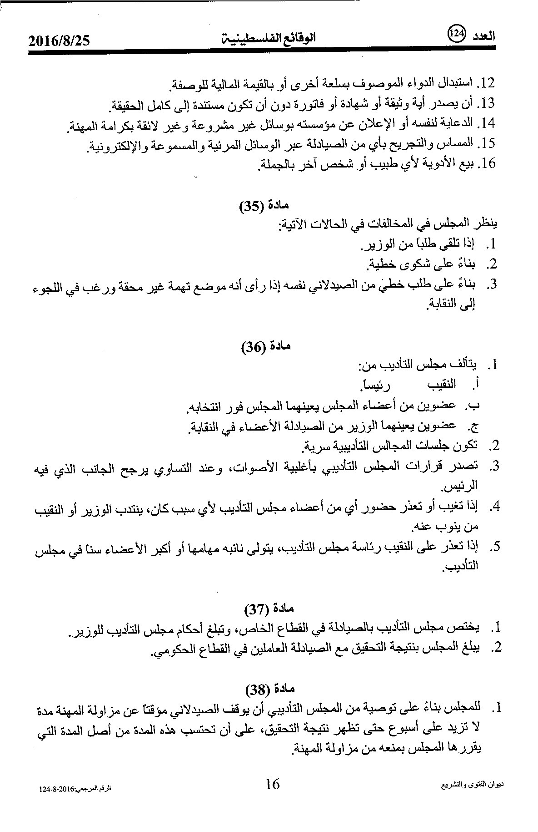](https://sites.google.com/site/ppasite2/home/News/qanwnnqabtealsyadlte/16.jpg?attredirects=0)

[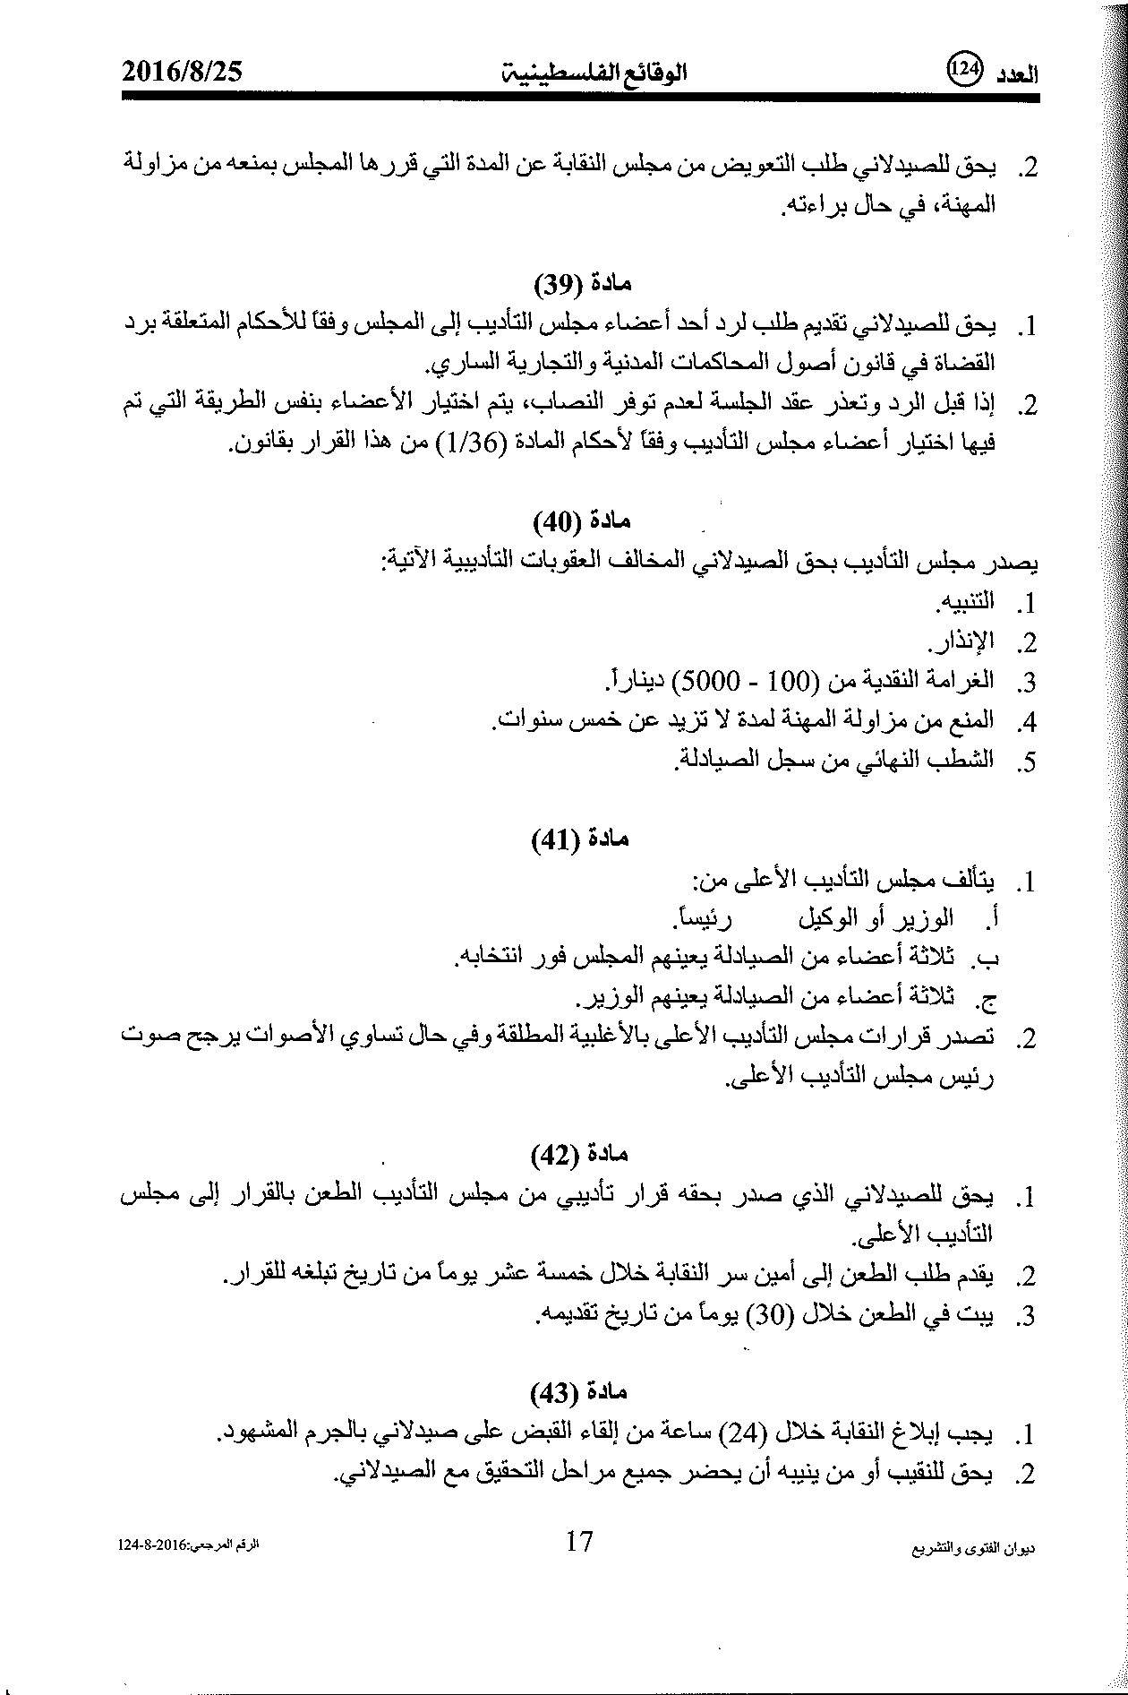](https://sites.google.com/site/ppasite2/home/News/qanwnnqabtealsyadlte/17.jpg?attredirects=0)

[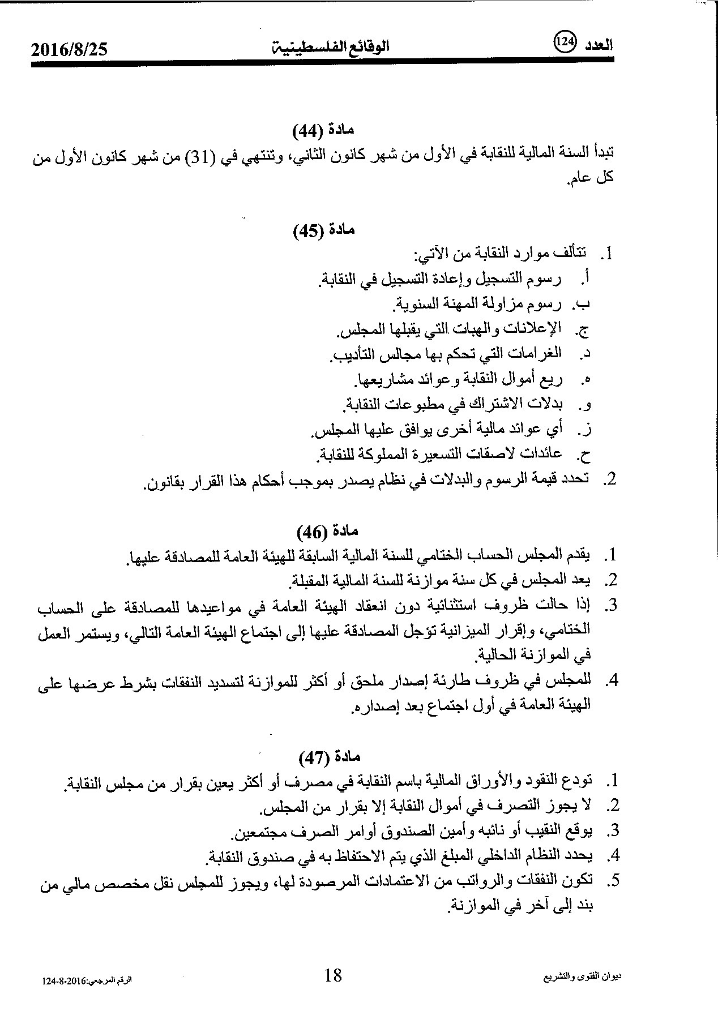](https://sites.google.com/site/ppasite2/home/News/qanwnnqabtealsyadlte/18.jpg?attredirects=0)

[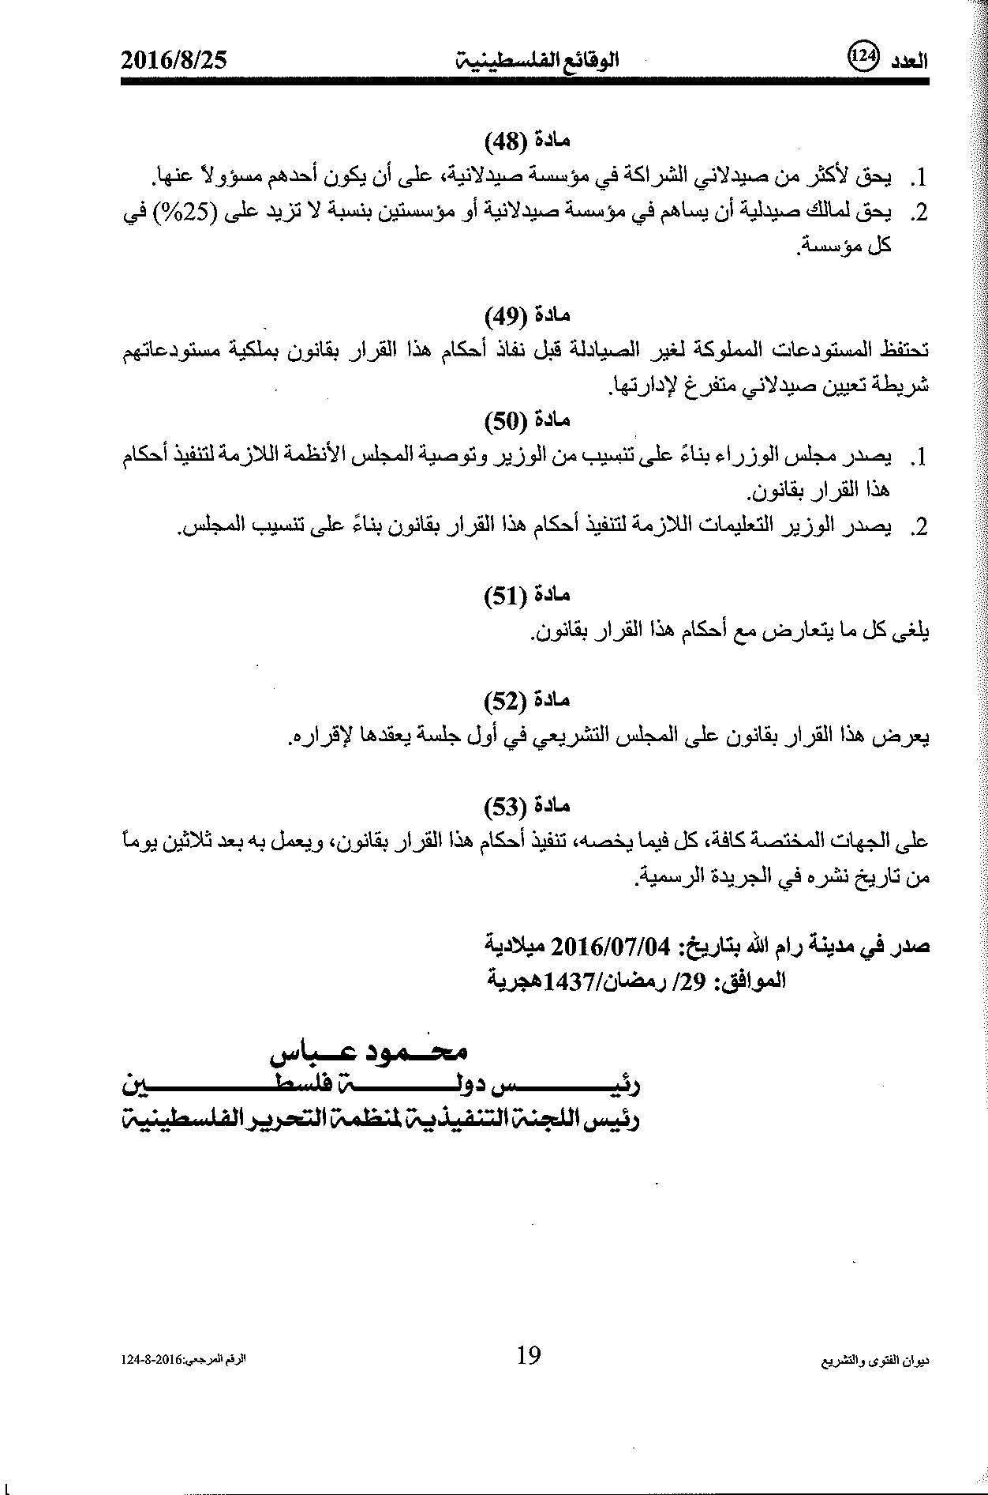](https://sites.google.com/site/ppasite2/home/News/qanwnnqabtealsyadlte/19.jpg?attredirects=0)